OVERVIEW
--------
Snowflake offers a free 30-day trial with $400 in credits. No credit card is required
to sign up. This guide walks developers through activating and setting up a Snowflake
trial account.

STEP 1: SIGN UP FOR A TRIAL ACCOUNT
------------------------------------
1. Navigate to: https://signup.snowflake.com/?t=f38802af46f08923faac6133744ea0e50f76e47121fb477dbeff26abbffd102b

2. Fill in the registration form:
- First Name, Last Name
- Email Address (use your work email)
- Why are you signing up?
- Company Name
- Job Title

3. Select your preferred options:
- Snowflake Edition: Select "Enterprise" for full developer features
- Cloud Provider: AWS
- Region: US EAST (Northern Virginia)
4. Click "GET STARTED" / "Continue"
5. Check your email for an activation link from Snowflake.

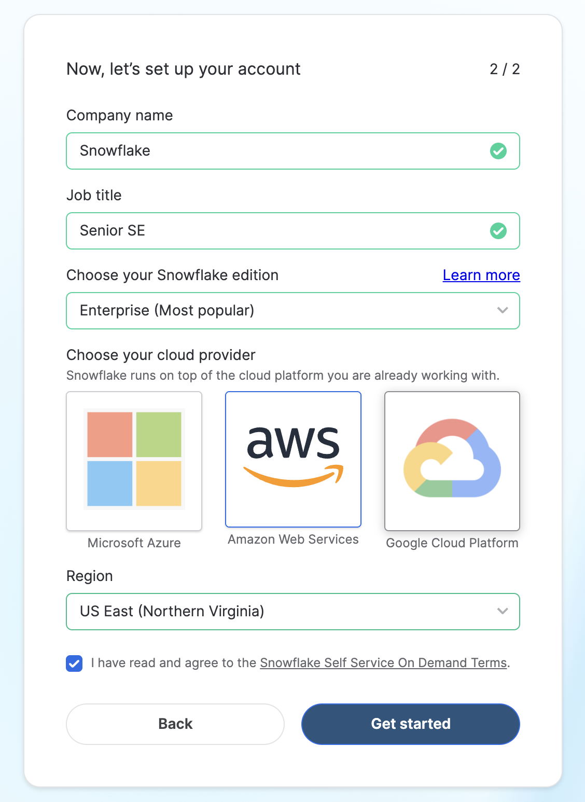
STEP 2: ACTIVATE YOUR ACCOUNT VIA EMAIL
-----------------------------------------
1. Open the activation email from Snowflake (subject: "Activate your Snowflake account").
2. Click the activation link in the email.
- Note: The activation link expires after 24 hours.
3. You will be redirected to a page to set your:
- Username
- Password (minimum 8 characters, must include uppercase, lowercase, number)
4. Click "Get Started" to complete activation.

STEP 3: LOG IN TO SNOWSIGHT (SNOWFLAKE UI)
-------------------------------------------
1. After activation, you will be redirected to Snowsight (the Snowflake web UI).
2. You are good to go with the Hands-on Lab

LINKS FOR HANDS ON LAB GUIDES

- Zero to Snowflake
HoL Guide: https://www.snowflake.com/en/developers/guides/zero-to-snowflake/

